Project 1
Due Sunday 1/29/2023 by 11:59 PM
No delay is accepted
For each day late submission 2 points penalty is incurred.
Post your answer in the folder: Project 1 on the https://pace.edu/classes.
If you have any question, please email me at mbadii@pace.edu

Note: If you do not have a group, you cannot upload your project.

1. Follow the steps in lecture 1 for UE4 to make the level explained in this lecture.
Note: Based on the last section of the lecture, if you do not like to add your picture, add a picture of the nature.

2. Change the desk and the chair by the following steps:
a) Click on the  and then on the menu bar click on: 
b) In the search window enter: free table to see:
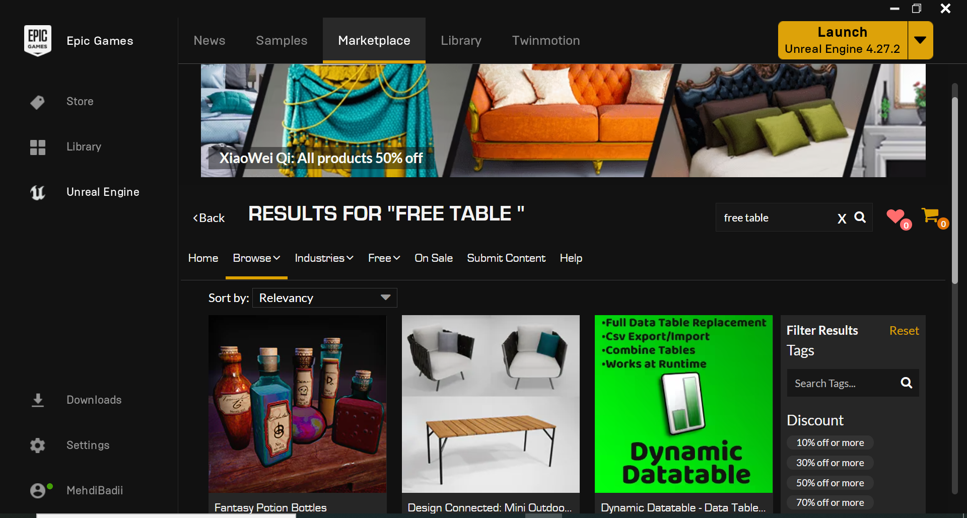

c) Click on the table to see:

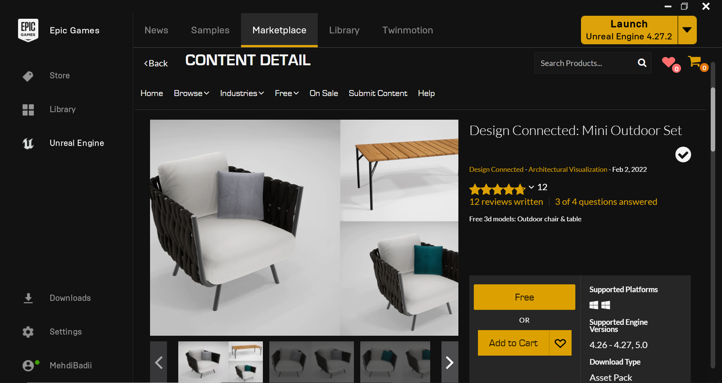

d) Click on: Free to see:

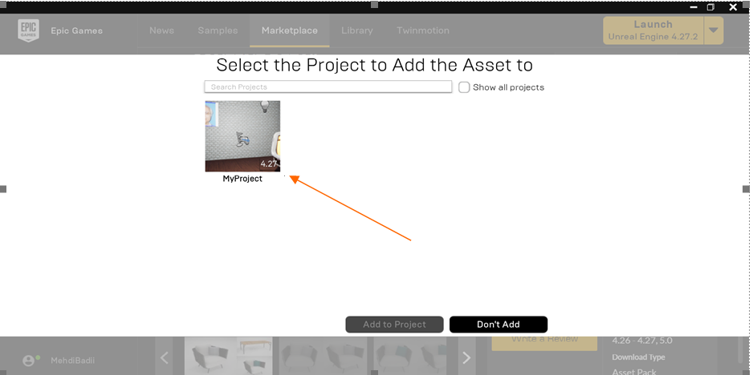

e) Click on MyProject to see:

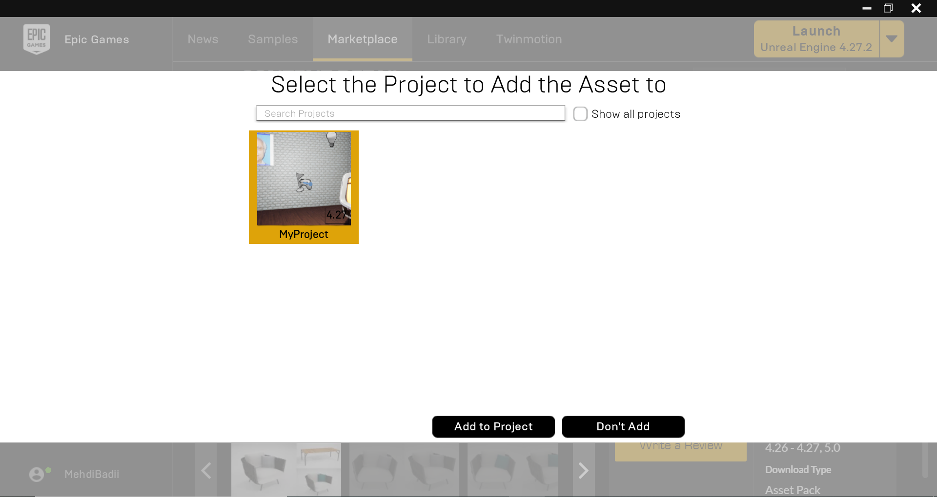

f) Click on: .

g) Close the Epic Games and load your game.

h) Click on Content → MiniOutdoorSet → Meshes → OutdoorChair

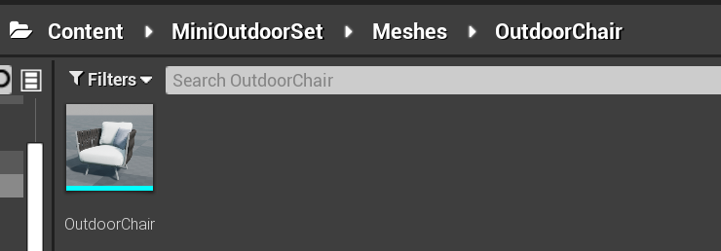

i) Replace the chair on the scene by the OutdoorChair.
j) Click on Content → MiniOutdoorSet → Meshes → OutdoorTable

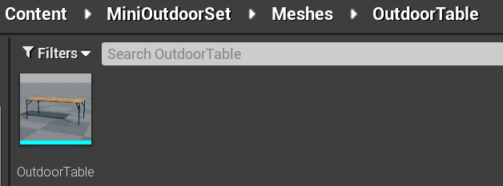

k) Replace the table on the scene by the OutdoorTable.

l) Select the table and on world outliner window, change the Scale: 1, 1, 1 to 0.5, 1, 1.

m) Make the scene such that the statute be on the table, and the chair be by the table:

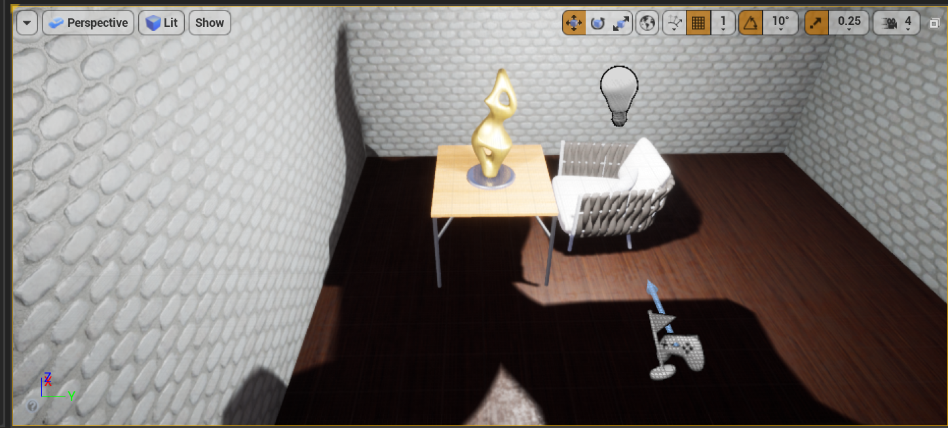

Note: Click on  to bring the top view and also the front view to make sure the chair and the disk are not stick under the floor, or on the air.
Note: Press the key: Spacebar to be able to rotate (if needed).

Note: Do not add the chair and the table into the folder: MyWork.

How to submit:
Inside the folder of your game, there is a folder named: MyWork. Zip this folder and upload.

Note: I do not grade, if you zip the folder: Content. You must not zip the folder: Content. Only zip the folder: MyWork.

